Track

Definition:
# Source: AI Source: Provided by: [Data Path: Persons Table -> ID Column: 1, Name_En Column: Motasem Essam] -> From: [ChatGPT] on [10/26/2025]
A track is an individual recorded piece of music. It can be vocal, instrumental, or a combination and is usually part of a larger collection, like an album or playlist.

🎶 Key Features:
# Source: AI Source: Provided by: [Data Path: Persons Table -> ID Column: 1, Name_En Column: Motasem Essam] -> From: [ChatGPT] on [10/26/2025]
- Can be a song with lyrics or an instrumental piece.
- Often labeled as Track 1, Track 2, etc. on albums or digital releases.
- Can be streamed, downloaded, or played individually.
- Can exist as a single track (standalone) or part of an album/playlist.

🎵 Examples:
# Source: AI Source: Provided by: [Data Path: Persons Table -> ID Column: 1, Name_En Column: Motasem Essam] -> From: [ChatGPT] on [10/26/2025]
- “Thriller” on Michael Jackson’s Thriller album — one track.
- “Imagine” by John Lennon — a single track.
- An instrumental piano piece released on Spotify as a track.

🧭 In Short:
# Source: AI Source: Provided by: [Data Path: Persons Table -> ID Column: 1, Name_En Column: Motasem Essam] -> From: [ChatGPT] on [10/26/2025]
Track = A single piece of recorded music, either standalone or part of a collection like an album.

Track = a basic unit of music — it’s general and flexible, and can belong to many categories depending on how it’s presented or performed.

Difference Between Track, Song, and Single
# Source: AI Source: Provided by: [Data Path: Persons Table -> ID Column: 1, Name_En Column: Motasem Essam] -> From: [ChatGPT] on [10/26/2025]
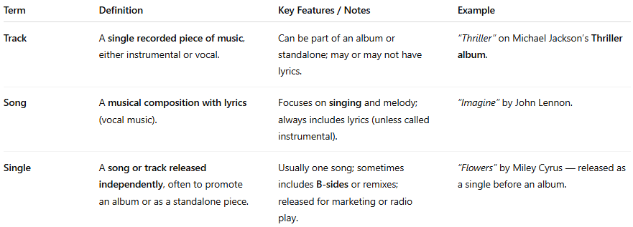
Term | Definition | Key Features / Notes | Example
Track | A single recorded piece of music, either instrumental or vocal. | Can be part of an album or standalone; may or may not have lyrics. | “Thriller” on Michael Jackson’s Thriller album.
Song | A musical composition with lyrics (vocal music). | Focuses on singing and melody; always includes lyrics (unless called instrumental). | “Imagine” by John Lennon.
Single | A song or track released independently, often to promote an album or as a standalone piece. | Usually one song; sometimes includes B-sides or remixes; released for marketing or radio play. | “Flowers” by Miley Cyrus — released as a single before an album.

In Short:
- Track = Any individual piece of recorded music (vocal or instrumental).
- Song = Track that has lyrics.
- Single = Track or song released separately, often to promote an album.

💡 Tip:
A single is always a track, a song can be a track, but not all tracks are songs (instrumentals are tracks but not songs).

